Page 3

Office Hours: 8:30 a.m. - 4:00 p.m

Bell Schedule for 2021-2022

Daily Bell Schedule – Mon, Tues, Thurs, Fri |  | Day 1 | Day 2
1st period  Flex time  Fle | 8:30 – 9:50 | A | B
2nd period | 9:55 – 11:22 | B | A
Lunch | 11:22 – 12:00
3rd period | 12:05 – 1:25 | C | D
4th period | 1:30 – 2:50 | D | C

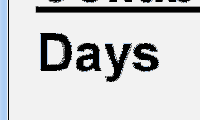
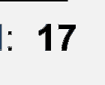
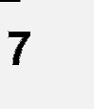
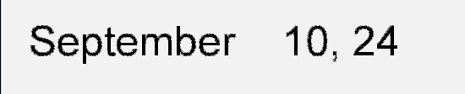
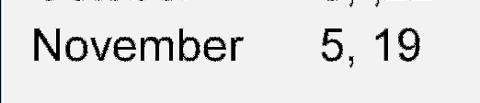
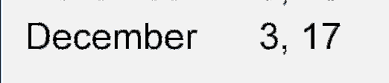
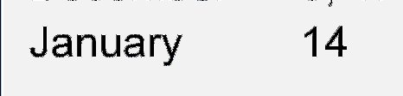
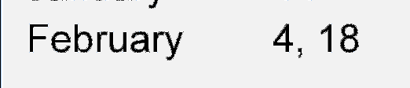
Collaboration Day Bell Schedule

Wednesday |  | Day 1 | Day 2
1st period | 9:35 – 10:39 | A | B
2nd period | 10:44 – 11:54 | B | A
Lunch | 11:54 – 12:32
3rd period | 12:37 – 1:41 | C | D
4th period | 1:46 – 2:50 | D | C

