NORTH DELTA SECONDARY SCHOOL

Bell Schedule for 2018-2019

Monday, Tuesday, Thursday and Friday |  | Day 1 | Day 2
1st period  Flex time  Fle | 8:30 – 9:40 | A | B
Flex Time | 9:45 - 10:25
2nd period | 10:30 – 11:40 | B | A
Lunch | 11:40 – 12:20
3rd period | 12:25 – 1:35 | C | D
4th period | 1:40 – 2:50 | D | C

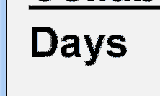
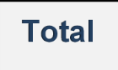
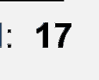
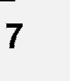
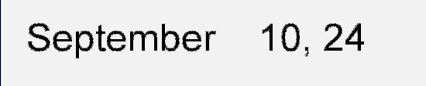
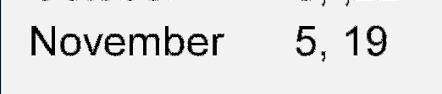
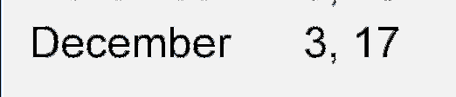
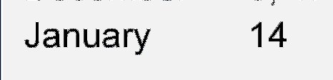
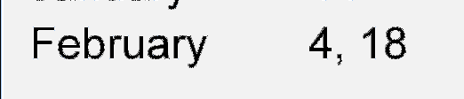
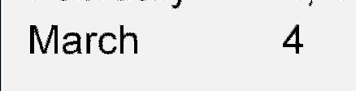
Collaboration Day Bell Schedule (Every Wednesday)

 |  | Day 1 | Day 2
1st period | 9:35 – 10:40 | A | B
2nd period | 10:45 – 11:50 | B | A
Lunch | 11:50 – 12:30
3rd period | 12:35 – 1:40 | C | D
4th period | 1:45 – 2:50 | D | C

Collaboration Days

September 12 January 30
September 26 Februry 13
October 10 February 27
October 24 March 13
November 7 April 10
November 21 April 24
December 5 May 8
December 19 June 5
January 16

GUIDANCE/DISCIPLINE: Mr. K. Dalgetty Gr. 9 & Gr. 11

Mr. R. Kirincic Gr. 8 & Gr. 10

Mr. A. Akune Gr. 12

COUNSELLORS
Grade 9  Grade 12 H - O | Ms. F. Cipriano | 231
Grade 11  Grade 12 A - G | Ms. R. Sharma | 229
Grade 10 | Mr. P. Plut | 234
Grade 8  Grade 12 P-Z | Ms. A. Kaila | 233

